

American International University-Bangladesh (AIUB)  
**Department of Computer Science  
Faculty of Science & Technology (FST)**

**ShobKaaj – One App for Every Task Near You.**

A Software Engineering Project Submitted

By

|  |  |  |  |  |
| --- | --- | --- | --- | --- |
| **Semester: Summer_25_26** | | **Section:** | **Group Number:** | |
| SN | Student Name | Student ID | Contribution (CO3+CO4) | Individual Marks |
| 1 | Syed Al Mahmud | 23-50168-1 | 40 |  |
| 2 | Tahmid Hasan Binoy | 22-46511-1 | 20 |  |
| 3 | Tahmid Jawad Shafi | 22-49127-3 | 20 |  |
| 4 | Md Jubair Hassan | 21-45641-3 | 20 |  |

The project will be Evaluated for the following Course Outcomes

|  |  |  |
| --- | --- | --- |
| **CO3:** *Select* appropriate software engineering models, project management roles and their associated skills for the complex software engineering project and evaluate the sustainability of developed software, taking into consideration the societal and environmental aspects | Total Marks | |
|  | |
| Appropriate Process Model Selection and Argumentation with Evidence | [5Marks] |  |
| Evidence of Argumentation regarding process model selection | [5Marks] |  |
| Analysis the impact of societal, health, safety, legal and cultural issues | [5Marks] |  |
| Submission, Defense, Completeness, Spelling, grammar and Organization of the Project report | [5Marks] |  |
| **CO4:** *Develop* project management plan to manage software engineering projects following the principles of engineering management and economic decision process | Total Marks | |
|  | |
| Develop the project plan, its components of the proposed software products | [5Marks] |  |
| Identify all the activities/tasks related to project management and categorize them within the WBS structure. Perform detailed effort estimation correspond with the WBS and schedule the activities with resources | [5Marks] |  |
| Identify all the potential risks in your project and prioritize them to overcome these risk factors. | [5Marks] |  |

Description of Student’s Contribution in the Project work

|  |
| --- |
| Student Name: Syed Al Mahmud  Student ID: 23-50168-1  Contribution in Percentage (40%):  Contribution in the Project:   * Use Case diagram * Class diagram * Project Proposal * Selection of Process model * Requirements * Software user interface * Risk management * Gantt Chart   **___________________**  Signature of the Student |
| Student Name: Tahmid Hasan Binoy  Student ID: 22-46511-1  Contribution in Percentage (20%):  Contribution in the Project:   * State diagram * Project Proposal * Selection of Process model * Requirements * Software user interface * Risk management   **___________________**  Signature of the Student |
| Student Name: Tahmid Jawad Shafi  Student ID: 22-49127-3  Contribution in Percentage (20%):  Contribution in the Project:   * Activity diagram * Project Proposal * Selection of Process model * Requirements * Software user interface * Risk management   **_____________**  Signature of the Student |
| Student Name: Md Jubair Hassan  Student ID: 21-45641-3  Contribution in Percentage (20%):  Contribution in the Project:   * Sequence diagram * Project Proposal * Selection of Process model * Requirements * Software user interface * Risk management   **___________________**  Signature of the Student |

# PROJECT PROPOSAL

## Background to the Problem

Bangladesh has a large and diverse workforce, consisting of skilled laborers, students, freelancers, homemakers, and unemployed rural youth. However, many of them face challenges in finding steady employment or trustworthy clients. Similarly, homeowners, students, and small businesses often need quick, reliable help for everyday tasks like tutoring, delivery, repairs, event setup, etc., but struggle to find verified workers.

The root cause of this issue lies in the fragmented and informal nature of job opportunities and service access in Bangladesh. There is no unified, trusted platform that connects people who need services with skilled individuals available nearby. Existing apps and job boards are either too niche (e.g., only for tutors or freelancers) or lack verification and safety features. Rural workers especially remain disconnected from digital job markets due to low tech access or platform relevance.

This problem is important because it affects both economic growth and social well-being. Millions remain underemployed or unemployed, while others face delays, scams, or high costs due to the lack of reliable help. Addressing this can improve income distribution, digital inclusion, and overall societal efficiency.

## Solution to the Problem

The objective of the proposed project, “ShobKaaj”, is to develop a secure, user-friendly mobile platform that connects clients and workers in one place for all kinds of local services. It will bridge the gap between job seekers (especially rural and underrepresented groups) and job providers, ensuring verified, efficient, and trustworthy transactions.

**Proposed Solutions:**

* GPS Matching: Clients and workers can find each other based on real-time locations.
* Verified Profiles: NID or mobile-based verification to ensure safety and trust.
* In-App Communication: Real-time chat to discuss job details.
* Digital Wallet Integration: Support for popular services like bKash, Nagad.
* Multilingual Support: Bangla-first interface with other options.
* Badges & Ratings: Encourage trust and reward quality service.

**Basic Functionalities:**

* Clients: Can post jobs with title, description, budget, deadline, and location; browse worker profiles; chat and hire; give ratings.
* Workers: Can build profiles with photos, skills, and experience; receive instant job alerts; apply and communicate; get paid and rated.
* Universal: Location-matching, in-app wallet, ratings, badge system, NID/phone verification, rural accessibility features.

**Target Users and Benefits:**

* Clients: Homeowners, students, event organizers, shopkeepers—get easy access to trustworthy local help.
* Workers: Students, women, freelancers, rural and semi-urban laborers—gain flexible work opportunities and verified payments.

**Scientific and Societal Contribution:**

“ShobKaaj” contributes to the development of digital marketplaces by combining location-aware algorithms, secure identity checks, and real-time communication in a single mobile app. It has cultural and social impact by enabling flexible work for women, promoting financial inclusion, and reducing digital inequality, especially for rural and semi-urban populations

**Literature Review:**

Global platforms like TaskRabbit, Upwork, and Fiverr focus on specific types of work such as freelancing or small household tasks. They work well in developed countries but do not support informal or local workers in places like Bangladesh. They also miss important features such as Bangla language, GPS-based worker search, mobile payments, and trust systems.

In Bangladesh, platforms like Bdjobs, Sheba.xyz, and Kormo Jobs are available, but each has limits. Bdjobs is mainly for office jobs, Sheba.xyz is for urban services like cleaning or repairs but lacks full support features, and Kormo Jobs gives entry-level work but does not include things like GPS, chat, or payments.

Because of these gaps, there is still no single platform in Bangladesh that connects both formal and informal workers with features like multi-job categories, real-time GPS matching, in-app chat, payments, and Bangla-first support.

**How “ShobKaaj” Extends Existing Solutions:**

* Covers more job types (blue-collar, small jobs, tuition, freelance).
* Stronger focus on rural, underrepresented users with a simplified Bangla interface.
* Combines chat + job matching + verification + payment in one app.
* Promote safe, flexible work through trust badges, live ratings, and local language support.

# SOFTWARE DEVELOPMENT LIFE CYCLE

## Process Model

**Nature and Environment of the Software**

**ShobKaaj** is a mobile application designed to connect clients with local workers across Bangladesh for various services. The software environment is:

* User-driven and evolving: especially with feedback from rural and underrepresented users.
* Feature-rich: including GPS-based matching, chat, verification, ratings, and mobile payments.
* Trust-sensitive: requiring secure identity checks and real-time communication.
* Cross-platform: with a focus on inclusivity, multilingual support, and usability on low-end devices.

This dynamic and feedback-heavy environment demands a flexible and iterative development process.

**Selected Model: Agile (Scrum)**

The Agile methodology, particularly the Scrum, is best suited due to:

* Flexibility in accommodating evolving requirements.
* Iterative delivery of features in sprints for faster feedback and improvement.
* User-centric development, with regular testing and adaptation based on real user input.
* Efficient collaboration among cross-functional teams.
* Early issue detection and continuous integration of improvements.

**Why Agile Over Other Models**

| Model | Limitation for ShobKaaj | Why Agile Is Better |
| --- | --- | --- |
| Waterfall | Rigid, no scope for mid-development change | Agile allows adaptive planning and change |
| V-Model | Testing-focused but inflexible | Agile includes testing in every sprint |
| RAD | Resource-intensive and prototype-focused | Agile balances speed with structure |

**Conclusion**

Agile (Scrum) is the optimal choice for ShobKaaj due to its adaptability, incremental delivery, and strong support for user-centered, secure, and scalable mobile app development.

## Project Role Identification and Responsibilities

The **ShobKaaj** project follows the **Scrum** methodology, where each role plays a vital part in ensuring the successful development and delivery of the platform. The following are the key roles and their responsibilities:

**1. Scrum Master**  
The Scrum Master ensures that the Scrum process is properly followed and that the project proceeds smoothly. They support both the development team and the Product Owner throughout the project.

**Responsibilities:**

* Facilitates Scrum events (Sprint Planning, Daily Scrum, Review, Retrospective).
* Supports the Product Owner in managing and prioritizing the Product Backlog.
* Coaches the development team in self-organization and productivity.
* Identifies and removes obstacles that hinder team progress.
* Serves as a communication link between the team, customer, and management.

**2. Scrum Team**  
The Scrum Team is a self-organizing, cross-functional group of professionals responsible for delivering product increments each sprint. Typically consisting of 3 to 9 members, the team works collaboratively without internal sub-divisions.

**Responsibilities:**

* Plans and completes sprint tasks and backlog items.
* Estimates effort and manages the Sprint Backlog.
* Delivery of high-quality, working product increments.
* Shares collective accountabilities for all outcomes.
* Continuously improves through team feedback and retrospectives.

**3. Product Owner**  
The Product Owner is responsible for maximizing the value of the product. They are the main decision-maker regarding the features and priorities of the application.

**Responsibilities:**

* Manages and prioritizes the Product Backlog.
* Defines and communicates clear product requirements.
* Makes final decisions on backlog changes.
* Represents business needs and user expectations.
* Collaborates with all stakeholders to ensure product alignment.

**4. Customer**  
The Customer is the end user or stakeholder who provides valuable input regarding product needs and usability. Their involvement ensures the final product aligns with real-world expectations.

**Responsibilities:**

* Contributes to backlog item discussions and refinements.
* Provides feedback during sprint reviews and testing phases.
* Validates that the delivered features meet their needs.

**5. Management**  
Management oversees the overall direction and resource allocation of the project. While not directly involved in Scrum ceremonies, their role supports the team’s structure and success.

**Responsibilities:**

* Sets goals, standards, and expectations for the project.
* Approves key decisions and monitors progress.
* Ensures the team has the tools, time, and support to deliver.
* Promotes an Agile culture and supports Scrum adoption.

**Diagrams**

**1.Usecase diagram**

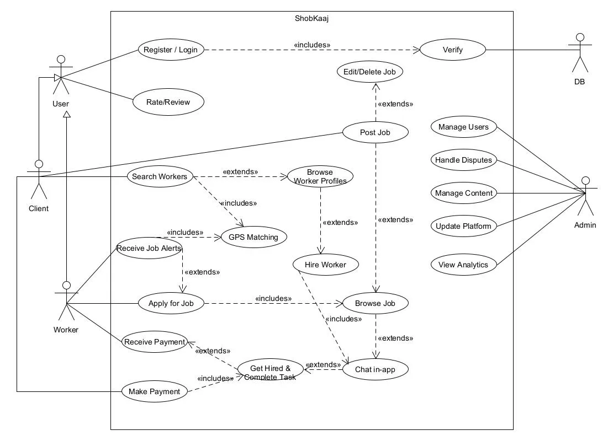

**2.Class diagram**

**3.State diagram**

**4.Activity diagram**

**5. Sequence diagram**

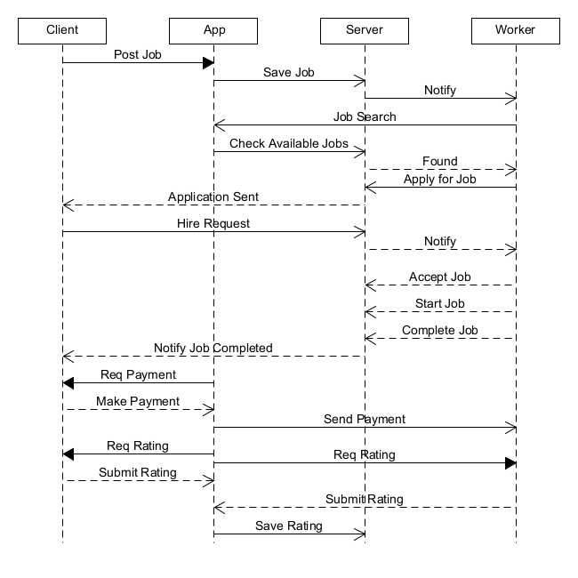

**Requirements**

**1. Functional Requirements**

| **ID** | **Requirement Description** |
| --- | --- |
| **FR1** | **Users must be able to register and log in using phone number or NID-based verification.** |
| **FR2** | **Clients can create job posts with a title, description, location, budget, and deadline.** |
| **FR3** | **Workers can browse, filter, and apply to jobs based on location, category, and skills.** |
| **FR4** | **GPS-based matching must connect clients with nearby available workers in real time.** |
| **FR5** | **Real-time in-app chat must be available between clients and workers.** |
| **FR6** | **Workers can create and manage profiles with photo, skills, and experience.** |
| **FR7** | **Clients and Workers must be able to rate and review after job completion.** |
| **FR8** | **The platform must support in-app digital payments through bKash and Nagad.** |
| **FR9** | **The app must support Bangla-first UI with optional rural dialect and English fallback.** |
| **FR10** | **Workers must receive real-time job alerts and earn trust badges based on performance.** |

**2. Non-Functional Requirements**

| **ID** | **Requirement Description** |
| --- | --- |
| **NFR1** | **The app must be optimized for smooth performance on low-end Android devices.** |
| **NFR2** | **The system must be scalable to support high traffic and a growing user base.** |
| **NFR3** | **All user data must be securely stored with encryption and secure authentication.** |
| **NFR4** | **The UI/UX must be intuitive and accessible to users with minimal tech literacy.** |
| **NFR5** | **The system should ensure 99% uptime and handle offline mode gracefully where needed.** |

**3. User Requirements**

| **User Type** | **Capabilities** |
| --- | --- |
| **Client** | **Register/Login, Post jobs, Browse worker profiles, Chat, Hire, Pay, Rate & Review** |
| **Worker** | **Register/Login, Create profile, Receive alerts, Apply to jobs, Chat, Get paid, Earn badges** |
| **Admin** | **(Optional) Verify users, moderate content, resolve disputes, manage reports** |

**4. System Requirements**

| **Component** | **Requirement** |
| --- | --- |
| **Platform** | **Android (initial), extendable to iOS and Web** |
| **Backend** | **RESTful API with secure data handling** |
| **Database** | **Centralized database for users, jobs, messages, ratings, payments** |
| **Payment Gateway** | **Integration with bKash and Nagad APIs** |
| **GPS Services** | **Location tracking and geo-matching logic** |
| **Chat System** | **Real-time communication (Firebase,** [**Socket.IO**](http://socket.io/) **or equivalent)** |
| **Notification System** | **Push notifications for job status and message** |

**COCOMO Estimation**

**We estimated the project size at 10,000 SLOC. Using the COCOMO Basic Model for an Semi-detached project:**

**Effort = PM = Coefficient<Effort Factor>*(SLOC/1000) ^P**

***Development time = DM = 2.50(PM)^T*\***

**Required number of people = ST = PM/DM**

**Where:**

* **10K SLOC**
* **Constants:**

| **Software Project Type** | **Coefficient<Effort Factor>** | **P** | **T** |
| --- | --- | --- | --- |
| **Organic** | **2.4** | **1.05** | **0.38** |
| **Semi-detached** | **3.0** | **1.12** | **0.35** |
| **Embedded** | **3.6** | **1.20** | **0.32** |

**Calculation**

**PM = 3.0× (10) ^1.05 ≈ 39.55**

**DM = 2.5× (39.55) ^0.35 ≈ 9 months**

**ST = 39.55/9 = 4.39Persons ≈ 5Persons**

**Adjustment to complete in 17weeks**

**Effort (BAC) = 39.55 PM**

**Duration (compressed) = 17 weeks (≈ 4.25 months)**

**Team Size = 39.55/4.25 ≈ 9-10Person**

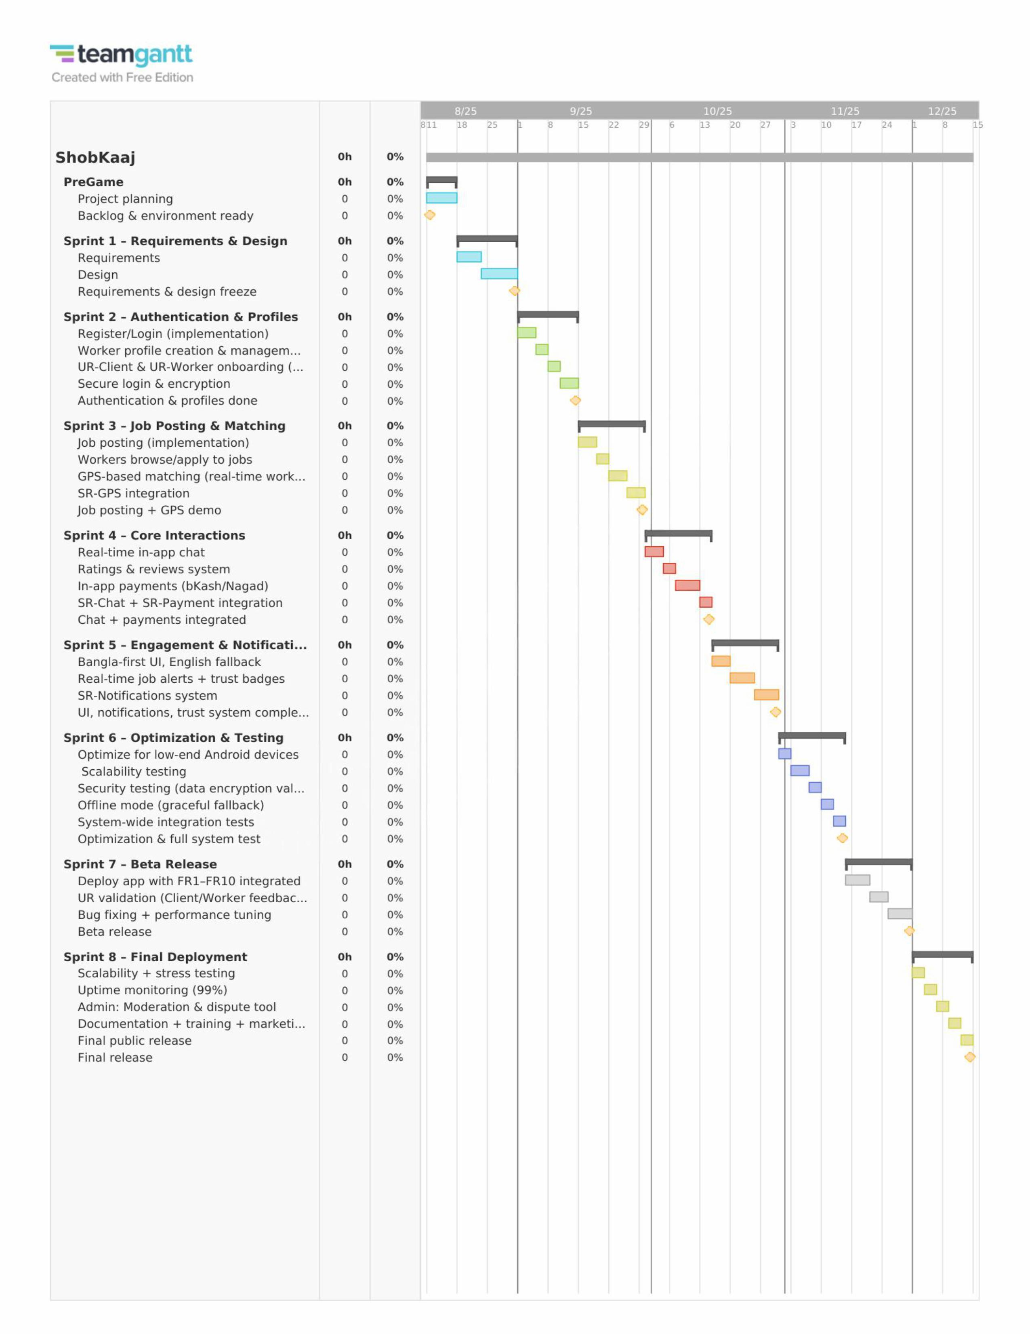**Gantt Chart**

Software user interface

Figma:<https://www.figma.com/design/jJarzBaAAiTopQT5vsmdqY/Final-Project?node-id=0->

**Risk Table**

| **Risk ID** | **Risk Name** | **Risk Probability** | **Risk Level** | **Risk Impact** | **Mitigation Plan** | **Notes** |
| --- | --- | --- | --- | --- | --- | --- |
| **Risk-1** | **Low Adoption by Clients & Workers** | **Medium** | **High** | **Without enough users, ShobKaaj won’t gain traction** | **Early marketing campaigns, referral bonuses, village/union partnerships, campus drives** | **Focus on rural & semi-urban outreach** |
| **Risk-2** | **App Bugs & Crashes on Low-End Devices** | **High** | **High** | **Workers may abandon app due to instability** | **Continuous QA testing on budget smartphones, beta releases, bug tracking** | **Bangladesh has high % of low-end phone users** |
| **Risk-3** | **Scalability Issues During Rapid Growth** | **Medium** | **High** | **App may slow down as user base increases** | **Cloud-based backend, load balancing, modular microservices** | **Plan phased rollout in major cities first** |
| **Risk-4** | **Payment Gateway Downtime (bKash/Nagad)** | **Medium** | **High** | **Failed transactions cause distrust** | **Integrate multiple gateways + fallback cash-on-delivery option** | **Maintain API monitoring & alerts** |
| **Risk-5** | **User Data Leak / NID Verification Breach** | **Low** | **Very High** | **Legal risks + loss of trust** | **Strong encryption, two-factor authentication, regular audits** | **Store minimal personal data** |
| **Risk-6** | **Inaccurate GPS Matching in Rural Areas** | **Medium** | **Medium** | **Wrong job-worker pairing leads to frustration** | **Allow manual location input if GPS fails** | **Test in low-connectivity areas** |
| **Risk-7** | **Regulatory Compliance with Govt. Digital Laws** | **Low** | **High** | **Risk of legal restrictions or shutdown** | **Consult legal experts, ensure NID verification aligns with govt. rules** | **Monitor ICT ministry updates** |
| **Risk-8** | **Limited Rural Accessibility (Network/Language)** | **Medium** | **Medium** | **Rural workers struggle with app usability** | **Bangla-first UI, offline-friendly features, local dialect support** | **Pilot in rural districts** |
| **Risk-9** | **Fake Profiles & Scams by Workers/Clients** | **Medium** | **High** | **Reduces trust in platform** | **Strict NID verification, admin moderation, report & block feature** | **Introduce trust badges & rating** |
| **Risk-10** | **Competition from Sheba.xyz / Kormo Jobs** | **Medium** | **Medium** | **Users may shift to alternatives** | **Differentiate via GPS-matching + rural inclusion + Bangla-first** | **Focus on underserved informal job market** |
| **Risk-11** | **Delayed App Development (Sprint Slippage)** | **Medium** | **High** | **Late delivery increases cost & risks** | **Strict sprint planning, buffer time, focus on MVP first** | **Track tasks with Scrum board** |
| **Risk-12** | **Server Downtime Affecting Job Matching** | **Medium** | **High** | **Clients & workers lose confidence** | **Cloud hosting, backup servers, auto-scaling, 24/7 monitoring** | **Maintain 99% uptime target** |

## Rubric for Project Assessment (CO3)

|  |  |  |  |  |  |
| --- | --- | --- | --- | --- | --- |
| Criteria | Marks distribution (Max 3X5= 15) | | | | Acquired  Marks |
| **Inadequate (1-2)** | **Satisfactory (3)** | **Good (4)** | **Excellent (5)** |
| Selection of Software Engineering Models | Does not articulate a position or argument of choosing appropriate model. Does not present any evidence to support the arguments for the choice of the model | Articulates a position or argument for choosing models that is unfocused or ambiguous. Presents incomplete/vague evidence to support argument for model choice | Articulates a position or argument of choosing models that is limited in scope. Does not present enough evidence to support the argument for the choice of the model | Clearly articulates a position or argument for the choosing software engineering models. Presents sufficient amount of evidence to support argument for the model selection |  |
| Role identification and Responsibility Allocation | The project has poor project management plans for identifying roles and assigning the responsibilities | Identify few roles in the project management where some of the roles are left alone with any project responsibilities | Identify most of the roles in the project management and assign their responsibilities | Well planned project with proper role identification and responsibility allocation in the project management activities |  |
| Impact identification |  |  |  |  |  |
| Formatting and Submission | Project report is not complete and Several errors in spelling and grammar. Present a Confusing organization of concepts, supporting  arguments, and  real-life example.  Sentences rambling, and details are repeated. | Some errors in spelling and grammar. Some problems  of organizing the answer in a logical order of defining,  elaborating, and providing real-life examples. | Few errors in spelling and grammar. Presents most of the details in a logical flow of  organization in  definition,  details, and  example. | Project report is complete and No errors in spelling and grammar. Consistently  presents a logical  and effective  organization of definition,  details, and real-life example of  the topic. |  |
| Acquired marks: | | | | |  |
| CO Pass / Fail: | | | | |  |

## Rubric for Project Assessment (CO4)

|  |  |  |  |  |  |
| --- | --- | --- | --- | --- | --- |
| Marking Criteria | Marks Distribution (Maximum 3X5=15) | | | | Acquired Marks |
| **Inadequate (1-2)** | **Satisfactory (3)** | **Good (4)** | **Excellent (5)** |
|  |  |  |  |  |  |
| Project Planning | No background information regarding the project is  given; project goals and benefits are  missing. | Insufficient background information is given; project goals and benefits are  poorly stated | Sufficient background information is given; the purpose and goals of the project are explained. | Thorough and relevant background information  is given; project goals are clear and easy to identify. |  |
| Effort Estimation and Scheduling | Student vaguely discuss the impact of societal, health, safety, legal and cultural issues in their project | Student provided with partial relevance to the impact of societal, health, safety, legal and cultural issues in their project | Student fairly provided the analysis to the impact of societal, health, safety, legal and cultural issues in their project | Student comprehensively provided the analysis to the impact of societal, health, safety, legal and cultural issues in their project |  |
| Risk Management | Ambiguous representative example. | Partially identify / indicate towards real-life example. | Real-life example is fairly connected towards the definition. | Comprehensively defend with real life example. |  |
| Acquired Marks: | | | | |  |
| CO Pass / Fail: | | | | |  |